Canton Creek Groundwater Channel Prescription Proposal to Western Forest Products

High quality groundwater channel opportunities have been located on the right and left banks of Canton Creek in the lower reach. The potential size of these projects are 2100 m² on the right bank or 350 meters long and 7800 m² on the left bank or 1.3kms long. These channels would potentially provide spawning and rearing habitat for chum, coho and trout. The combined carrying capacity of these sites is estimated at 13,200 chum adults and 13,200 coho smolts or 500 adults.

Canton Creek Escapements

Year | Sockeye | Coho | Pink | Chum | Chinook
1953 | UNK | 1500 | UNK | 3500 | 400
1954 | UNK | 1000 | UNK | 4500 | 300
1955 | UNK | NO | UNK | 400 | 25
1956 | UNK | 75 | 75 | 200 | 25
1957 | UNK | 75 | UNK | 200 | 25
1958 | UNK | 200 | 25 | 1500 | 25
1959 | UNK | 200 | NO | 750 | 200
1960 | UNK | 75 | 25 | 15000 | 75
1961 | UNK | 75 | 25 | 750 | 25
1962 | UNK | 750 | 200 | 750 | 200
1963 | UNK | 400 | UNK | 600 | 600
1964 | UNK | 400 | 25 | 1500 | 400
1965 | UNK | 750 | 25 | 750 | 400
1966 | UNK | 600 | 75 | 550 | 250
1967 | UNK | 500 | NO | 900 | 500
1968 | UNK | 200 | 1500 | 3500 | 400
1969 | UNK | 75 | NO | 3500 | 400
1970 | UNK | 300 | 400 | 700 | 500
1971 | UNK | 750 | NO | 500 | 400
1972 | UNK | 200 | 1500 | 3500 | 400
1973 | UNK | 25 | UNK | 750 | 25
1974 | 25 | 200 | 75 | 3500 | 25
1975 | UNK | 200 | UNK | 1500 | 75
1976 | 25 | 200 | 25 | 400 | 25
1977 | UNK | UNK | UNK | 500 | UNK
1978 | 75 | NO | NO | 800 | NO
1979 | 10 | 30 | UNK | 140 | UNK
1980 | UNK | UNK | UNK | 5000 | UNK
1981 | 25 | 100 | UNK | 7000 | 20
1982 | 100 | UNK | UNK | 8000 | UNK
1983 | UNK | UNK | UNK | 5000 | UNK
1984 | 0 | 0 | 0 | 4500 | 35
1985 | 100 | UNK | UNK | 5500 | 30
1986 | 20 | 230 | UNK | 4900 | NO
1987 | UNK | 71 | UNK | 300 | UNK
1988 | UNK | UNK | UNK | 2500 | UNK
1989 | UNK | UNK | UNK | 5500 | UNK
1990 | UNK | UNK | UNK | 3200 | UNK
1991 | UNK | 30 | UNK | 5000 | 100
1992 | UNK | 30 | UNK | 5900 | 900
1993 | 200 | 100 | NO | 28500 | 800
1994 | UNK | UNK | UNK | 12000 | 5000
1995 | 6 | 549 | NO | 2964 | 1615
1996 | 36 | 393 | NO | 8000 | 398
1997 | 148 | 323 | 23 | 25464 | 140
1998 | 126 | 1369 | 1 | 40629 | 620
1999 | 41 | 662 | NO | 9922 | 140
2000 | 35 | 3418 | NO | 1496 | 973

Prior to operation of Conuma Hatchery, mean escapement in Canton Creek from 1953 to 1979 was 1894 adults. Based on these records, it appears that the maximum escapement supported in this watershed was 3500 adults. Following hatchery operation escapements have increased to a mean of 9108. This is almost a 5-fold increase suggesting that more than 50% of the returns are of hatchery origin and that there is not enough spawning habitat in the stream.

Self-sustainability and bio-diversity of wild chum salmon in this watershed can only be preserved by maintaining and restoring spawning habitat in the watershed. Providing approximately 10,000 m² of spawning habitat for the wild chum will increase wild reproduction and reduce hatchery contribution to less than 50% which is consistent with the SEP guidelines. This restoration work will provide the same benefits to wild coho as well.

DFO Strategy:

Ensure that self-sustainability and bio-diversity is maintained in each conservation unit.
Maintain healthy wild production on systems in the SCD that provide high diversity and have high potential for naturally colonising or introducing new genes in local watersheds.

Ensure that all unique stocks are maintained

Focus on watersheds that will likely be threatened by development (Land management/protection)

Focus on watersheds that have high public interest

Focus on watersheds where available restoration/enhancement techniques can have be effective.

Target on watersheds and/or tributaries that have an escapement of <200- 500 coho adults, small to medium size watersheds, and are overwhelmed by hatchery returns.

DFO proposes to monitor grdwater levels throughout the proposed length of the identified channels. This will require the use of a 20 ton track excavator for 2 days to dig and install 10 shallow test wells, water level recording of the wells every 2 weeks during the summer/fall months, and a total station survey of the 2 sites during the winter.
DFO will prepare design drawings and cost estimates for both channels and submit these to Western by January 15, 2004. Project construction could be done as early as July 2004.

Costs:

Canton Creek Prescription | Cost | Cost
 |  | (in-kind)
Activity
excavation of test pits- EX 200 12 hrs in/out charges | $ 2,180
stand pipes/caps | $ 120
test pipe labour | $ 250 | $ 250
test pit monitoring (in-kind DFO Conuma Hatchery |  | $ 400
Survey | $ 3,000
Design |  | $ 3,000
Totals | $ 5,550 | $ 3,650

Total Required from Western Forest Products (FIA) = $5,550

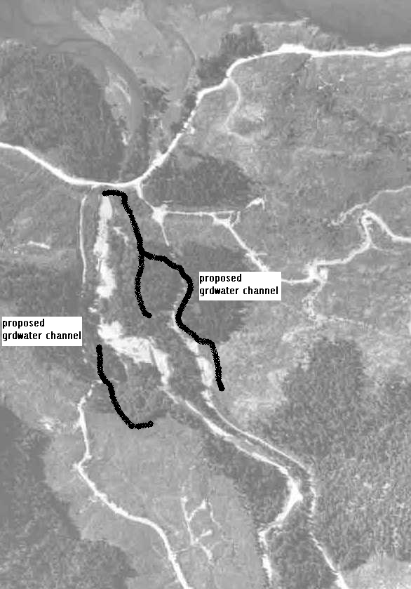
Canton Creek Aerial- Approximate Location of Proposed Groundwater Channel Sites

