Mooyah River Side Channel

Objectives
The objective of this project was to increase stable rearing area by re-establishing, and restoring, a historic drainage pattern that had been diverted as a result of a 1960’s landslide.

FRBC Region / MELP Region
Pacific / Vancouver Island

Author(s)
Warren Warttig, RPBio, Dave Clough RPBio

Proponent
International Forest Products, KEFD

Funding Sponsors 2000/2001
Interfor, KEFD (FRBC)$ 10,000
Interfor, West Coast Operations, $8,000
Regional Aquatic Management Society (FishRBC) $20,000

Watershed / Location
The Mooyah River watershed is located just North of Clayoquot Sound in the southwestern region of Nootka Sound. It can be accessed by boat (one-hour trip) out of Gold River, or out of Tofino by boat to Stewardson Camp, and then driving one hour North.

Introduction
The Mooyah River supports Chum, Coho, Steelhead, and Chinook salmon, Cutthroat Trout and Dolly Varden Char. It has had historic logging impacts dating back to the early 1900’s, which has resulted in aggradation, loss of LWD, and hydrological changes. The Mooyah River watershed is classified as a “Target” Priority Key watershed in the Regional Management Plan. As well, the Nootka/Kyuquot SFA Committee has identified Mooyah River as a priority for restoration, and enhancement of Chinook. It is an important source of food fish for the Mowachaht/Muchalaht First Nations.

The mainstem of Mooyah River has an abundance of relatively stable spawning habitat, but lacks adequate stable rearing habitat. To address sediment source issues Interfor has had an ongoing restoration program in the Mooyah watershed since 1998. During 1999, and 2000 many of the high risk roads were deactivated to a high standard, with the remainder slated for completion in 2001.

During the early 1960’s, several logging related landslides impacted the Mooyah River. In one location a landslide had filled in a palaeo channel and diverted the original stream course. The flow from this stream would then braid and eventually go sub-surface. The re-establishment of this area was identified as a restoration opportunity.

Assessments and Prescriptions
Funded through FishRBC, Level 1 and Level 2 assessments were conducted on the watershed in 1999/. Further FRBC Level II surveys were completed during 2000/01 for an additional side channel to be constructed in 2001/02 2000 (D.R. Clough, RPBio, W Warttig, RPBio).

Rehabilitation Work
Construction work began August 25, 2000 and ended September 15, 2000. On the 25th a hoe trail was laid out and constructed approximately 20m from, and parallel to the proposed side channel with several short, branching spurs. While slightly more difficult, this approach enabled the side channel to be constructed while retaining most of the riparian vegetation.
Figure 1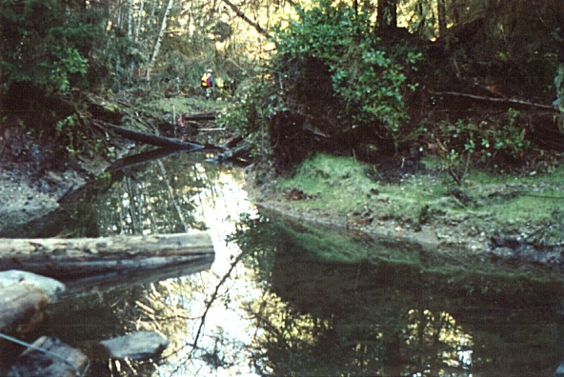 Completed channel with riparian vegetation intact

Channel construction began by grubbing the layer of fine organic soil off the surface down to the sandy gravel layer, then proceeded with side channel excavation. Placement of material was often double casted to areas of higher ground, and/or between blown down trees and root wads where a “cup like” area was evident. All exposed soil was grass seeded and planted with Salmon Berry cuttings. This approach enabled construction without the use of a dump truck for end hauling.

Complexing was completed with a combination of LWD and rock placement by hoe and by hand with a turfer jack. Anchoring of the structures was through a combination of rock ballast and duckbill anchors.

The final phase involved the re-establishment of the historic drainage pattern. A new armoured channel was constructed into the slide track, and a new drainage structure was installed on the Mooyah mainline logging road.

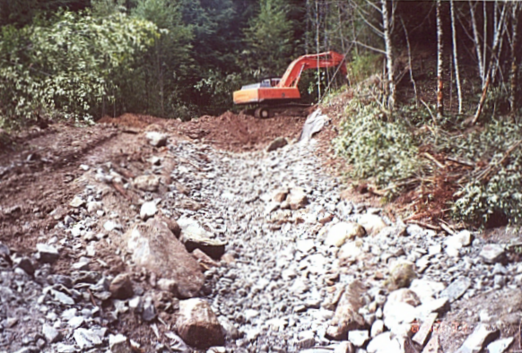Figure 2 Re-establishment of historic channel into slide track

Outputs
A total of 650m of side channel (approximately 700 m² based on wetted width) and one, 200 m² rearing pond were constructed. Interfor donated approximately 70 pieces of LWD for complexing.

Production Estimates
The habitat improved or made accessible in 2000 of 900 m² could produce 1,800 Coho fry based on the DFO bio-standard of two fry per square meter. Cutthroat Trout and Chinook salmon will also utilize the area.

For Further Information, Contact:
Warren Warttig, RPBio
Kingcome Enhanced Forestry Division
International Forest Products
P.O. Box 36 2960 Spit Road
Campbell River, B.C. V9W 4Z9
Tel: (250) 286 4547 ext. 24
Email: warren_warttig@interfor.com

References
W. Warttig, RPBio, overview, 1999
D.R. Clough, RPBio, W. Warttig, RPBio, Level I and Level II, March 2000
DFO FISS records and BC16 escapement records (Fisheries officer notes)

Watershed Code
Mooyah River – 930491500, RMP management number 231

