RVT | Stand Condition | Function Impaired | Area  (ha) | Recommended Treatment | Desired Future Condition
1 | Brush dominated, poorly stocked conifer component  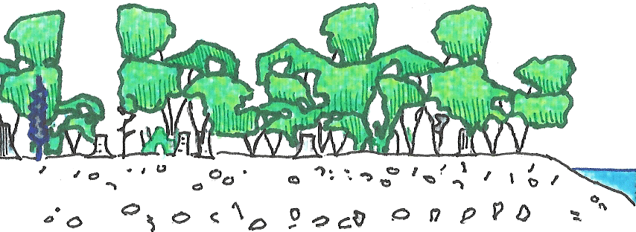 | Large wood, shade, bank and floodplain stability | 2.25 | Improve conifer stocking by planting. Release suppressed trees through competition removal and/or spot fertilizing  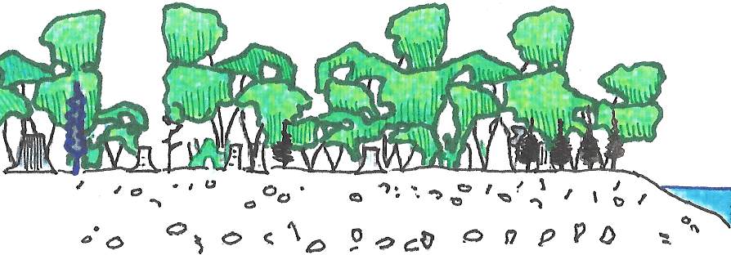 | 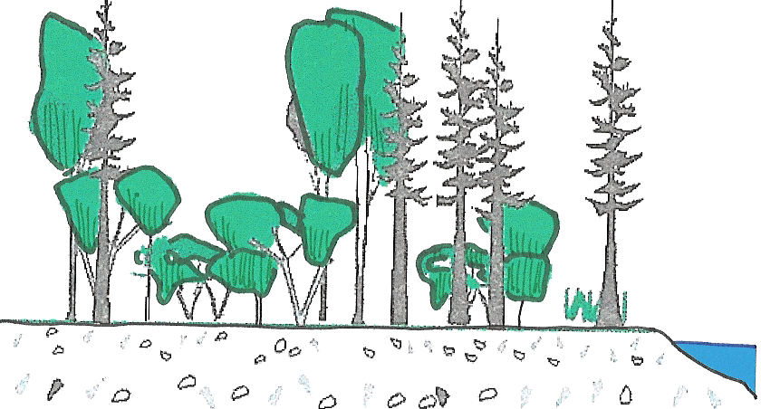
2 | Over stocked conifer, >800 stems per ha  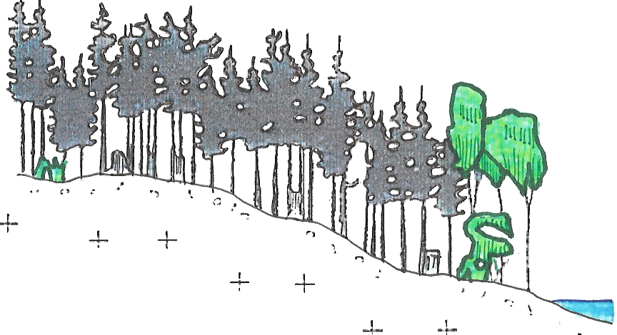 | Large wood, forage for wildlife, structural diversity | 3.77 | Thin to 400-600 sph, favouring largest diameter trees; vary densities creating gaps and clusters. Opportunities for bird and bat nests, and wildlife trees.  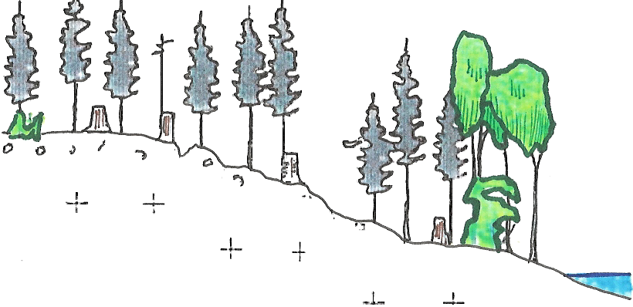 | 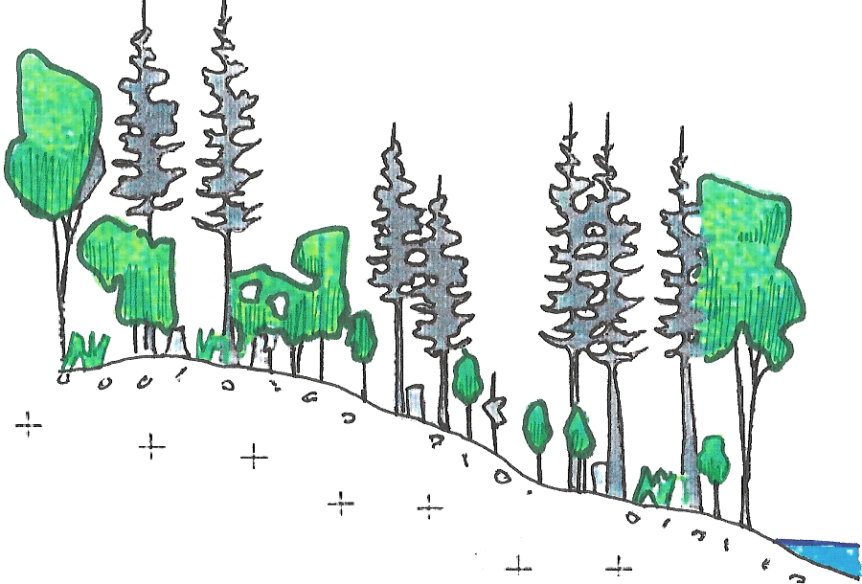
3 | Deciduous forest over top a good conifer understory  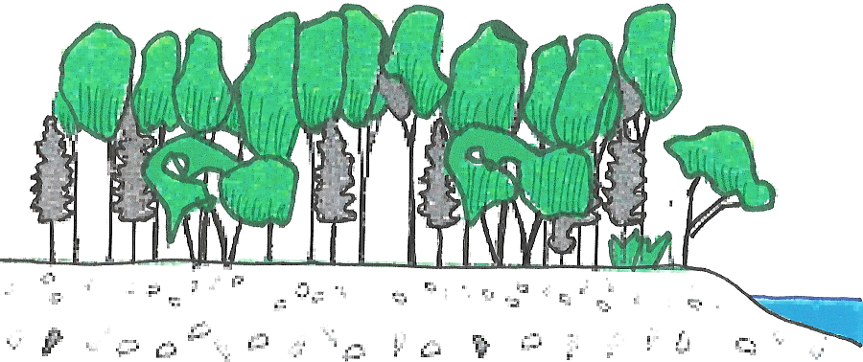 | Large wood, bank and flood plain stability | 0.00 | Release over topped conifers through competition removal and/or spot fertilizing  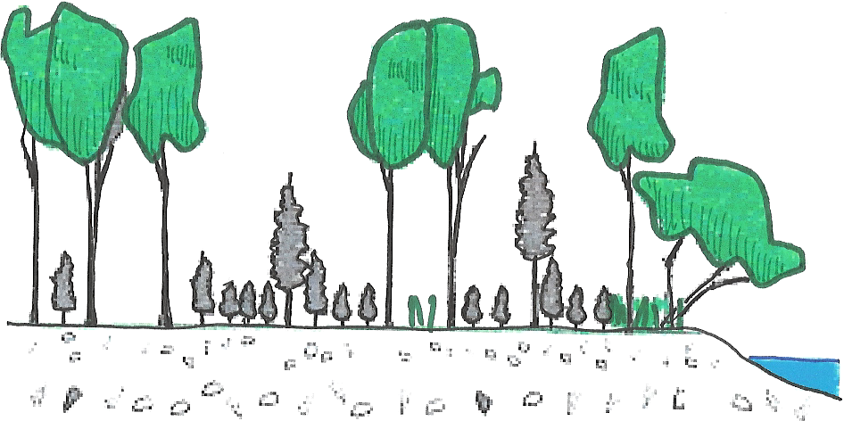 | 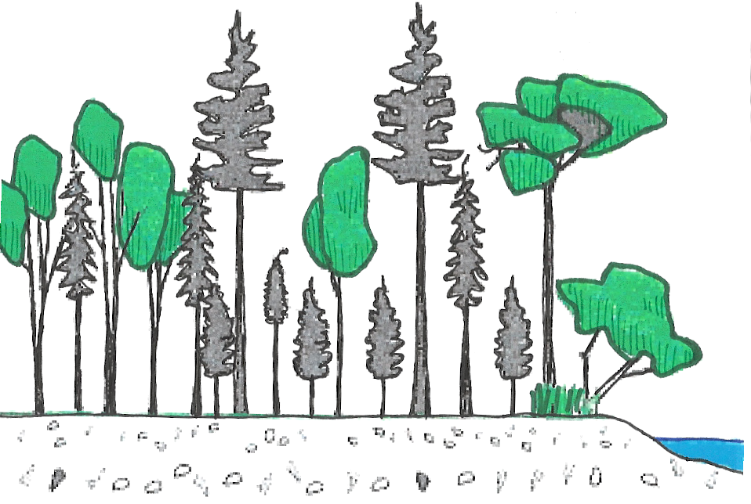
4 | Deciduous forest over top a poor conifer understory  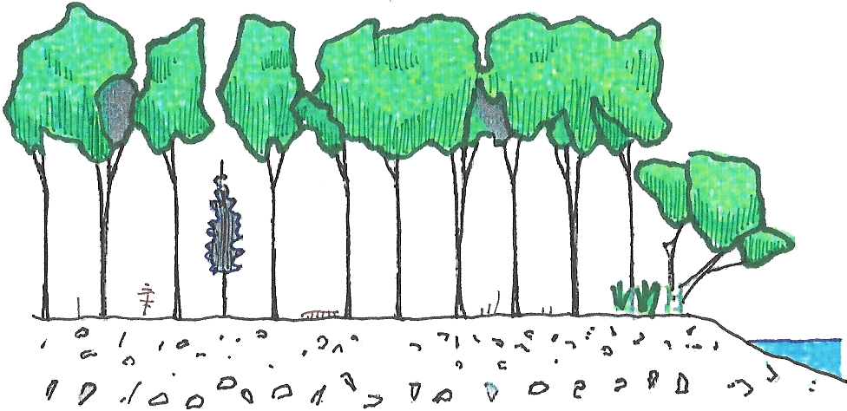 | Large wood, structural diversity, bank and flood plain stability | 3.54 | Improve conifer stocking by planting. Release suppressed trees through competition removal and/or spot fertilizing  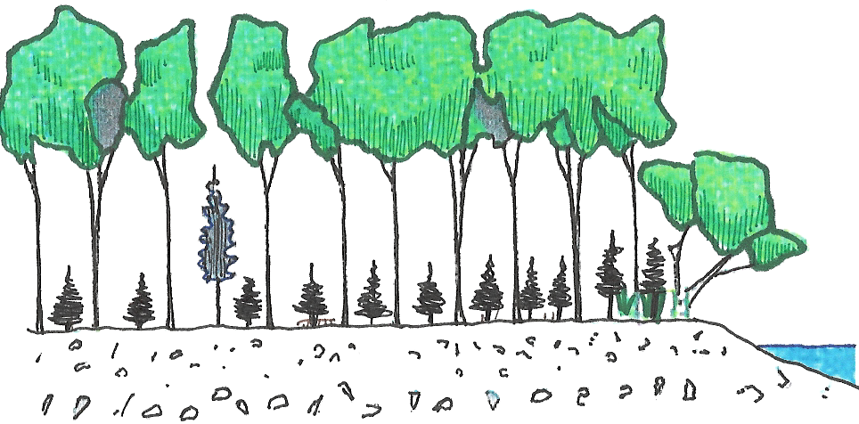 | 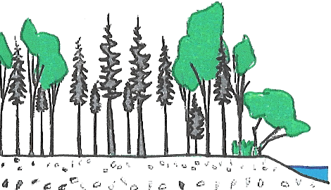
5 | Old growth, or old second growth (>70 years) | N/A | 1.17 | No treatment required | N/A
6 | Untreatable | Road, Parking Lot, Sediment Source | 1.67 | Grass seeding, bioengineering, sill logs, road maintenance | Well vegetated, good water management
TOTAL RIPARIAN AREA |  |  | 12.40
Hutchinson Creek Riparian Vegetation Types, and Their Recommended Restoration Treatments

