Project Completion Abstract

Big Bend Creek Riparian Restoration

Objectives
The objective of this project was to construct a Newbury Weir and place large woody debris instream on Big Bend Creek. Working with Gold River Streamkeepers, Mowachaht/Muchalat First Nations, Western Forest Products, Ministry of Transportation, Conuma Excavating and involving the local highschool streamkeepers in an educational and beneficial project.

FIA Investment Schedule Number
COTFL196348
FIA Project Number
6348003

Recipient Name and Division
Western Forest Product Limited
Gold River Forestry Operations

MoF District
Forest District Campbell River

MoF Region
Coast

Author(s) of the Project Completion Abstract
Dave Clough, RPBio
6966 Leland Road
Lantzville B.C. V0R 2H0
drclough@island.net (Ph:250-390-2901)

Watershed / Stream
Gold River/Big Bend Creek

UTM (NAD 83) Coordinates
Zone: 09
Northing: 5516000
Easting: 711500

Location
Big Bend Creek is located in the upper lower reach of Gold River near town. It drains from Big Baldy Mountain at 1611 m elevation off steep slopes. The lower 3.0 km of Big Bend Creek are fish habitat with the lower approximately 2.5 km anadromous to 500 m above the highway culvert. The creek is located just outside of town between the Conuma Excavating Pit and the Highways Maintenance Yard. Overhead are the Hydro Power lines from the old pulp mill site.

Introduction
Big Bend Creek has suffered from historic logging practices, highway culverts and ditching. It has been building up with a gravel bedload in the lower sections for quite some time due in part to these issues. The pool just below the highway culvert was too deep which impeded access for salmon during low flows. The Gold River Streamkeepers have been working on restoration projects in the area for approximately 5 years with a strong school program involvement. The Streamkeepers coordinated stage two of the restoration of Big Bend Creek and included an educational-hands on component for their school program. Jim Mitchell and Paul Smith of GR Streamkeepers worked on the arrangements. The highway culvert area was agreed upon early as the next priority item on the Big Bend restoration Plan after the riparian restoration. An overview assessment had been completed in previous years with a habitat assessment completed in 2004 by GR Streamkeepers and Dave Clough of the section below the highway culvert.

Planning and Preparation
The project began with a site assessment of the impacted stream bed area below the highway culvert. The appropriate measurements were taken by Dave Clough (biologist) and Stream Keeper members. Meetings were held with the GR Streamkeepers and they in turn contacted local school officials to facilitate a field day. They also contacted local contractors about site preparations and materials for the weir. The construction plan was reviewed by the biologist in consultation with a ministry of transportation expert Sean Wong. Domenico Iannidinardo, Western Forest Products staff was involved in the providing tools, and materials. Dave Davies, Community Advisor , DFO was also notified and invited to view the project. Fisheries staff and educators from the Mowachaht/Muchalat First Nation participated in the assessment and Roger Dunlop of NTC Fisheries also provided support and input.

Action
Dave Clough and members of the Gold River Streamkeepers along with Conuma Excavating started the work required to prepare for installing the Newbury weir. Trees were removed with permission from WFP. Once this work was complete, the hauling in of rock for the weir and logs for the instream woody debris were next. Once the weir was completed, work began by the streamkeeper members to build the woody debris structures. After everything was completed, the high school students, First Nations and members of the stream keepers planted trees in the excavated areas adjacent to the creek. Members of the stream keepers have been monitoring the work on a regular basis since completion.

Conclusions
The project was successful at accomplishing its objectives of:
- Increasing habitat and providing easier passage to and through the highway culvert to the upper sections of Big Bend Creek.
- Stewardship through partnership building with all community groups (GR Skprs, Schools, WFP, MMFN)
- Education- this Newbury Weir project was part of the GR Streamkeepers educational program in the area schools. It was a highlight for fall activities, more are planned for spring.

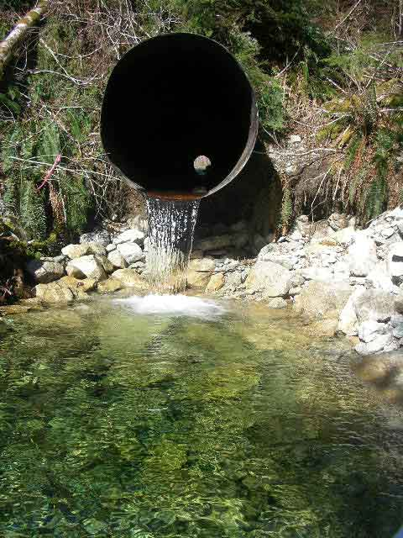
Pic.1) View looking directly at culvert.

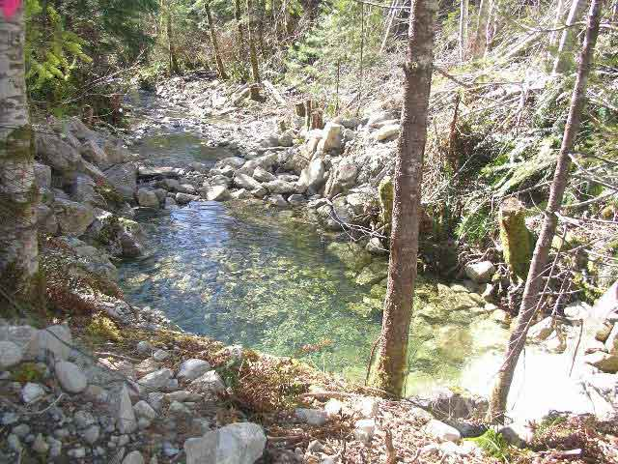
Pic. 2) View looking downstream of culvert.

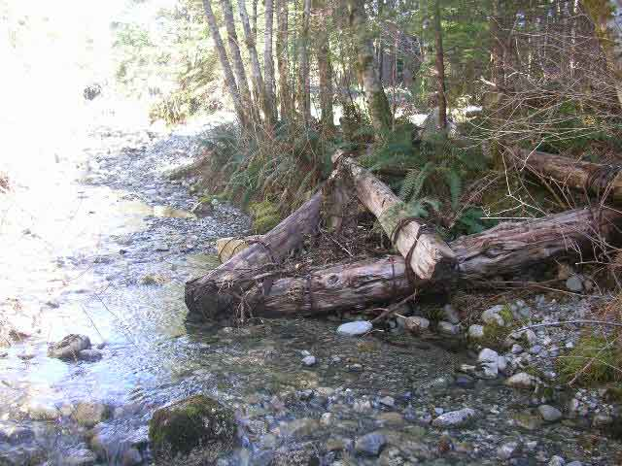
Pic. 3) View of first large woody debris structure.

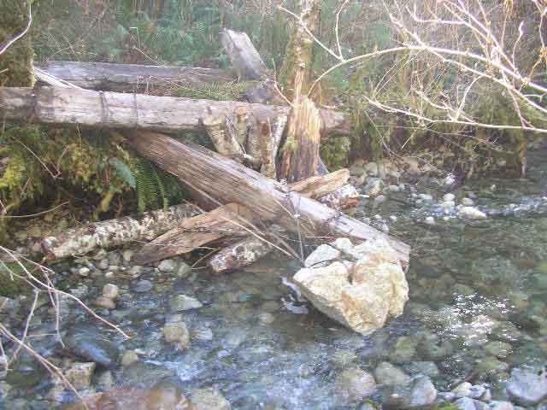
Pic. 4) Third Large woody debris structure.

Cost Summary
Materials/Rock/PitRun | $804.60
Biologist/Engineer | $2,370.97
Contractors/Equipment | $4,310.40
In Kind Contributions | $5,240.00
Total | $12,725.97

For Further Information, Contact:
Ken Hall, Manager, Environmental Restoration & Certification Audits
Western Forest Products Limited
Tel: (250) 286-4120
E-mail: khall@westernforest.com

