Project Completion Abstract

Big Bend Creek Riparian Restoration

Objectives
The objective of this project was to recover a severely altered riparian area of Big Bend Creek. Working with Gold River Streamkeepers, Mowachaht/Muchalat First Nations and involving the local highschool streamkeepers in an educational and beneficial project.

FIA Investment Schedule Number
COTFL196219
FIA Project Number
6219017

Recipient Name and Division
Western Forest Product Limited
Gold River Forestry Operations

MoF District
Forest District Campbell River

MoF Region
Coast

Author(s) of the Project Completion Abstract
Dave Clough, RPBio
6966 Leland Road
Lantzville B.C. V0R 2H0
drclough@island.net (Ph:250-390-2901)

Watershed / Stream
Gold River/Big Bend Creek

UTM (NAD 83) Coordinates
Zone: 09
Northing: 5516000
Easting: 711500

Location
Big Bend Creek is located in the upper lower reach of Gold River near town. It drains from Big Baldy Mountain at 1611 m elevation off steep slopes. The lower 3.0 km of Big Bend Creek are fish habitat with the lower approximately 2.5 km anadromous to 500 m above the highway culvert. The creek is located just outside of town between the Conuma Excavating Pit and the Highways Maintenance Yard. Overhead are the Hydro Power lines from the old pulp mill site.

Introduction
Big Bend Creek has suffered from historic logging practices, highways culverts and ditching. It also has continually had its riparian area under the hydro transmission area treated with herbicides or mechanical pruning/removal. The impact is quite noticeable in summer where this is the only area in the upper reach that dries in summer. The Gold River Streamkeepers have been working on restoration projects in the area for approximately 5 years with a strong school program involvement. The Club asked the author to assist them in restoration of Big Bend Creek and include educational-hands on component for their school program. Jim Mitchell and Paul Smith of GR Streamkeepers worked on the arrangements. The riparian area was agreed upon early as the highest priority item on the Big Bend restoration Plan. An overview assessment had been completed in previous years with a habitat assessment completed in June 2003 by GR Streamkeepers of the upper reach.

Planning and Preparation
The project began with a Sep. 18/03-site assessment of the impacted riparian area under the Hydro Lines. The area was measured, soil types, gradient and existing vegetation noted. An area 30 m long on either side of the creek was identified. Meetings were held with the GR Streamkeepers and they in turn contacted local school officials to facilitate a field day. They also contacted local contractors about site preparations to improve plant growing conditions. The planting plan was reviewed by the biologist in consultation with a riparian expert Richard Wahlgren, at Streamside Native Plants. Plants were then ordered and shipped the week of planting in October. Additionally BC Hydro staff were notified of the plans under their easement. This included verbal permission to plant and allow machine access under the wires.
Domenico Iannidinardo, BIT, Western Forest Products staff was involved in the planting plans with advice on site preps species and materials for the planting day. Dave Davies, Community Advisor , DFO was also notified and invited to planting day. Fisheries staff and educators with Mowachaht/Muchalat First nations were informed as well.

Action
GR Streamkeepers scheduled Oct 30 as a field day for orientation of stream habitat, riparian training and riparian planting.
The site was scraped and leveled by Conuma Excavating on Oct 28 & 29.
The plants were delivered to the site Oct 29.
A meeting was held at the school Oct 30 before the field trip began by all parties – DFO, WFP, GRSKPRS, M/MFN and myself.
On Oct. 30 a field trip to the Hutchinson Creek sidechannel was lead by Jim Mitchell. P. Smith and D. Davies.
In the AM, Plants were color coded for easy placement by their wet/dry or mixed soil moisture preference by D. Iannidinardo and D. Clough.
At Noon a lecture on Riparian planting was undertaken by D. Clough, D. Iannidinardo, and Marie Robertson, WFP Forester. Handouts on planting strategy were distributed by GRSkprs.
The afternoon was spent with approximately 30 people (22 students) planting approximately 650 potted plants.
There was site follow-up by GR Streamkeepers to ensure the last plants were placed. There will be a maintenance plan to ensure they are watered this summer by GRSKPRS.

Conclusions
The project was successful at accomplishing its objectives of:
- Habitat recovery of in important riparian area over a coho stream.
- Stewardship through partnership building with all community groups (GR Skprs, Schools, WFP, MMFN)
- Education- this planting project was part of the GR Streamkeepers educational program in the area schools. It was a highlight for fall activities, more are planned for spring.

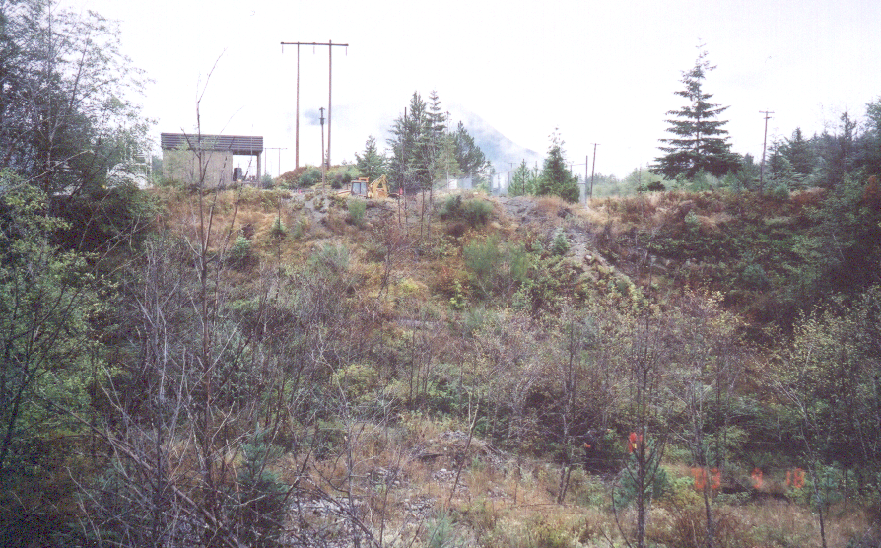
Pic.1) Big Bend Hydro Site – before restoration.

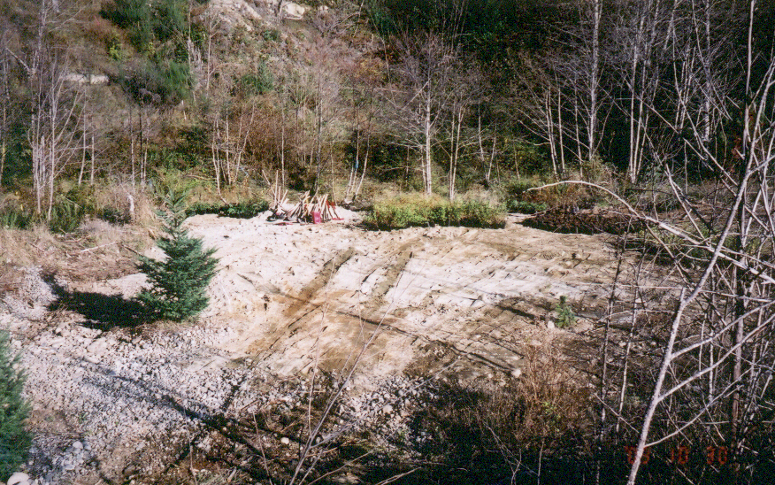
Pic. 2) Ground preps and plants on site.

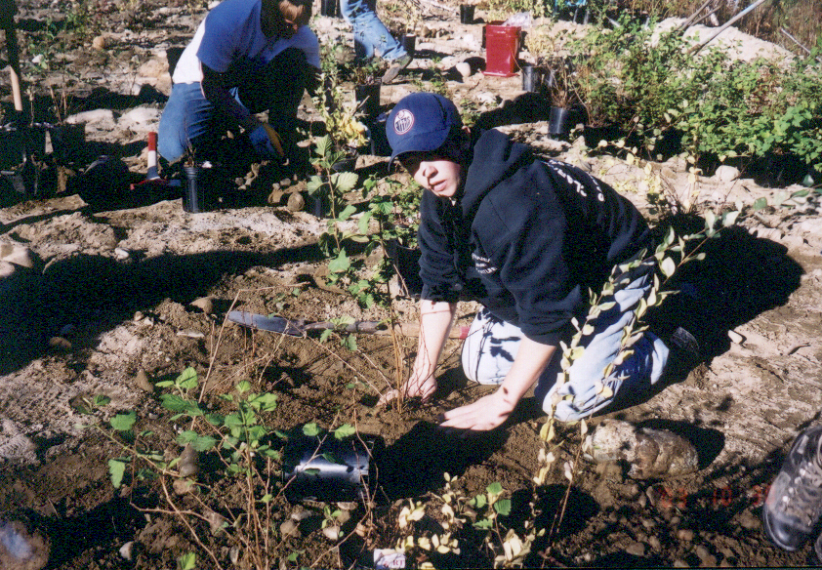
Pic. 3) Planting trees in Riparian Zone.

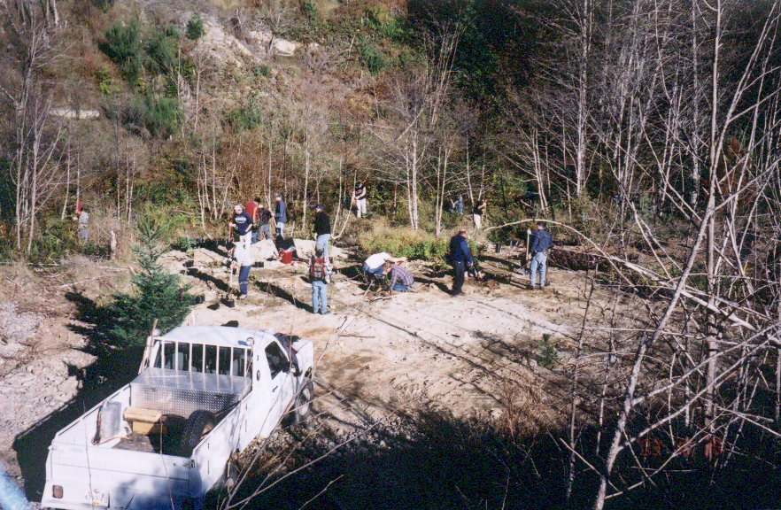
Pic. 4) Near complete planting site, Oct. 30/03.

Cost Summary
Plants | $4,185.38
Labour (Consultants) | $938.85
Total | $5,124.23

For Further Information, Contact:

Ken Hall, Manager, Environmental Restoration & Certification Audits
Western Forest Products Limited
Tel: (250) 286-4120
E-mail: khall@westernforest.com

